COACH FLIGHT DETAILS

Conor Lynch Flight Details Anchorage to Denver 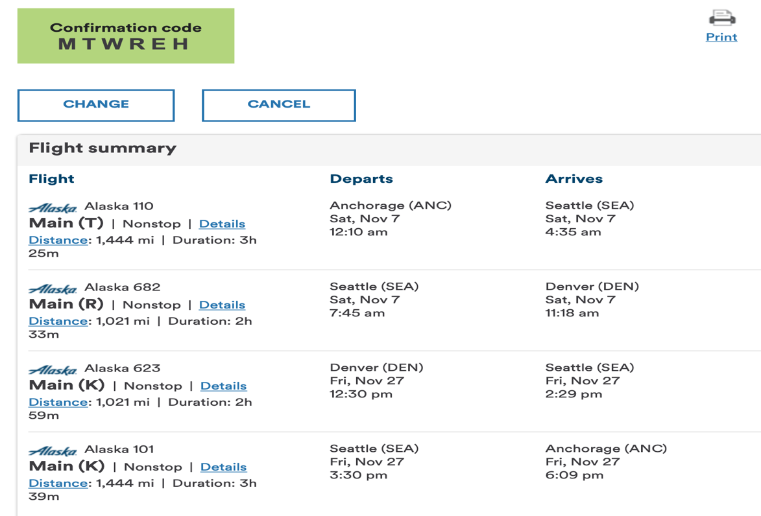

Conor McDonald Flight Details Anchorage Denver

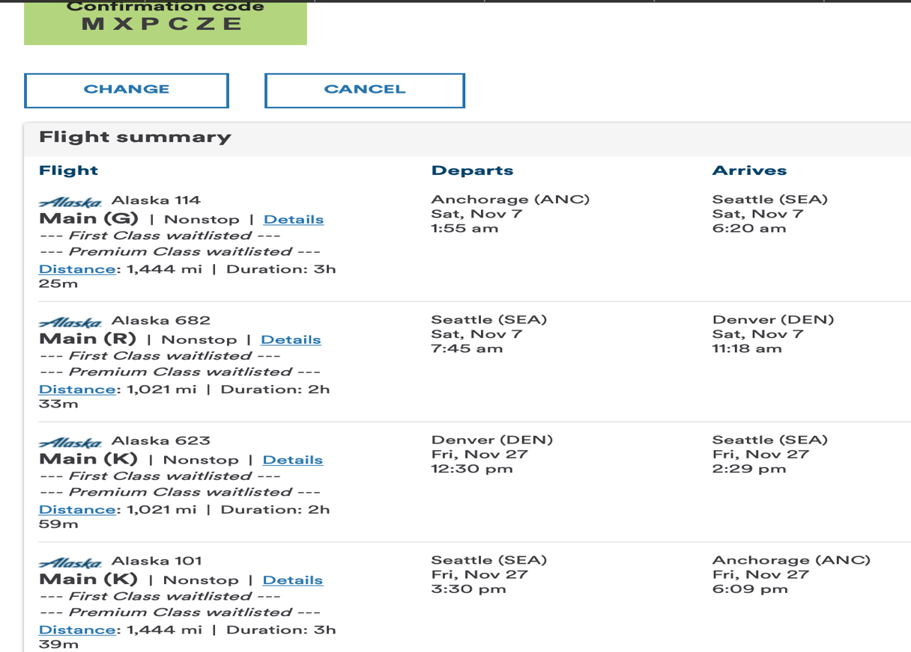

Jen Danza Flight Details Anchorage Bozeman
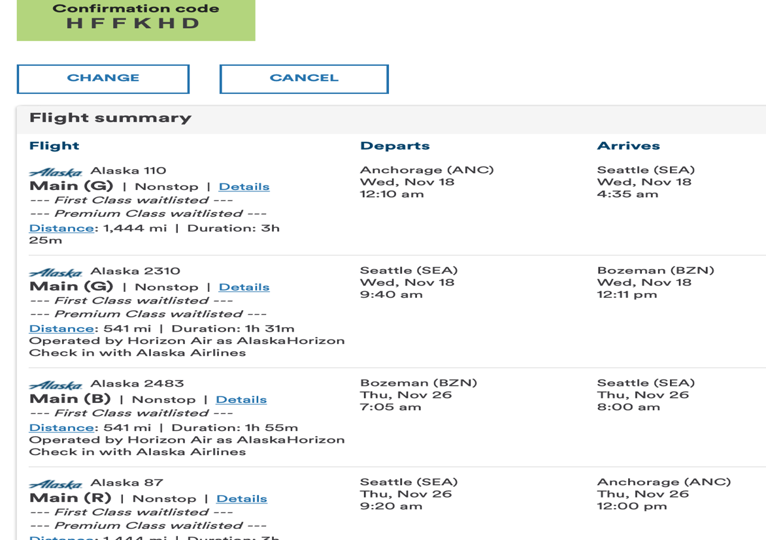
Sarah Lundgren Flight Details Anchorage to Bozeman
